**Week 7 ANOVA**

1. **MIXED ANOVA**

**ADDRESSING THE ASSUMPTION OF MIXED WAY ANOVA**

|  |  |  |  |  |  |  |
| --- | --- | --- | --- | --- | --- | --- |
| **Tests of Normality** | | | | | | |
|  | Kolmogorov-Smirnova | | | Shapiro-Wilk | | |
| Statistic | df | Sig. | Statistic | df | Sig. |
| training 01 | ,174 | 15 | ,200* | ,899 | 15 | ,092 |
| training 02 | ,213 | 15 | ,066 | ,899 | 15 | ,092 |
| training 04 | ,196 | 15 | ,126 | ,903 | 15 | ,106 |
| training 03 | ,199 | 15 | ,115 | ,913 | 15 | ,150 |
| *. This is a lower bound of the true significance. | | | | | | |
| a. Lilliefors Significance Correction | | | | | | |

**Interpretation**

The tests of normality were carried out by Kolmogorov- Simonov test and Shapirio-wilk and the results shows the test of normality is valid since at alpha 0.5 level for all training *p >.05.*

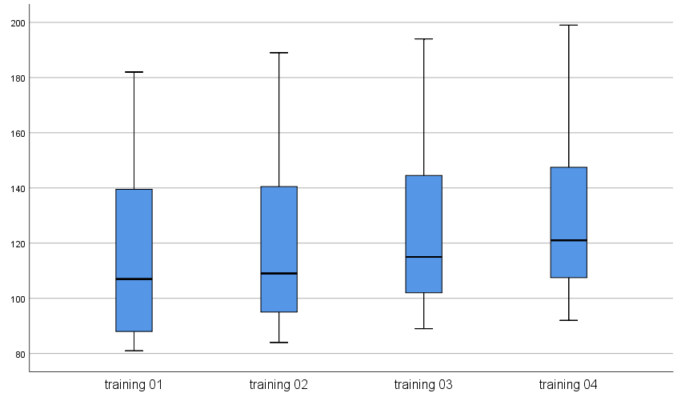

Across all groups the group training has no outlier thus the normality assumption is valid.

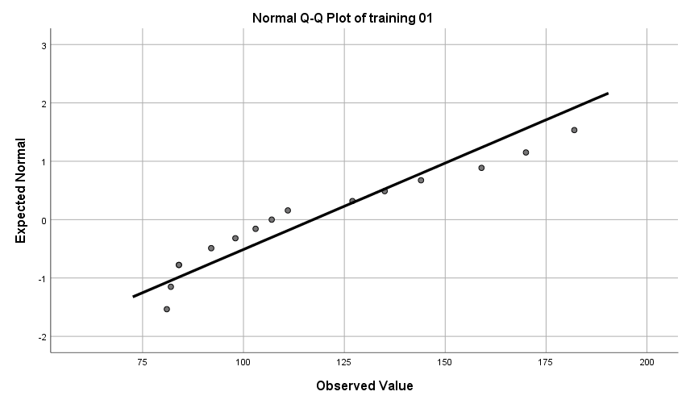

The point is closer to the straight line thus this reveals the assumption of normality is valid and not violated.

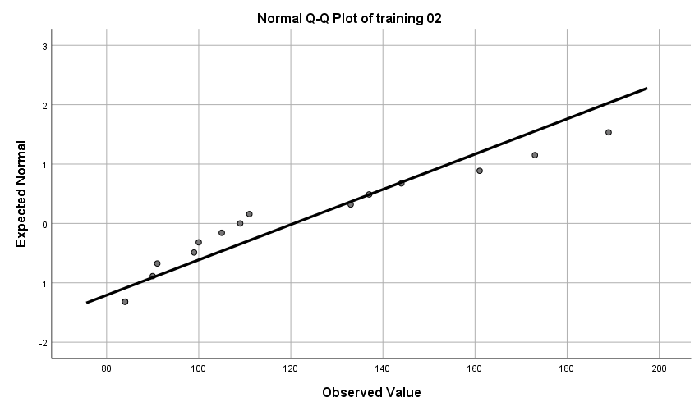

The point is closer to the straight line thus this reveals the assumption of normality is valid and not violated.

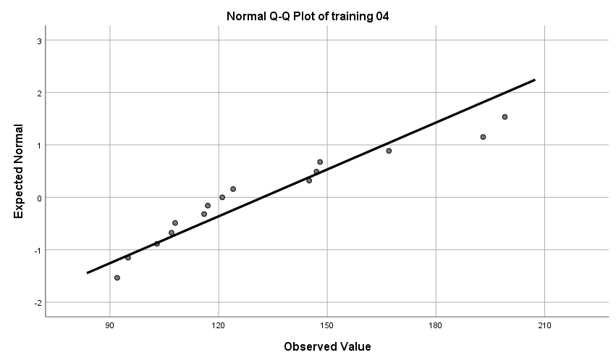

The point is closer to the straight line thus this reveals the assumption of normality is valid and not violated.

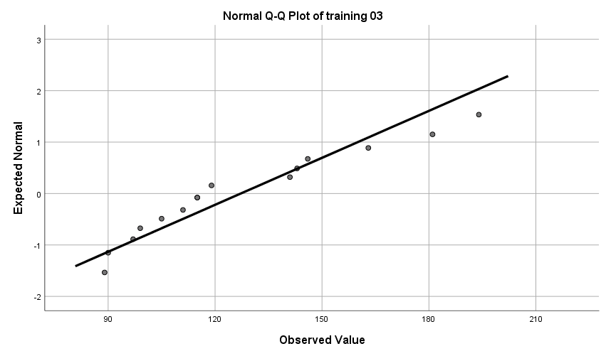

The point is closer to the straight line thus this reveals the assumption of normality is valid and not violated.

**Test of Homogeneity of variance**

|  |  |  |  |  |  |
| --- | --- | --- | --- | --- | --- |
| **Levene's Test of Equality of Error Variancesa** | | | | | |
|  | | Levene Statistic | df1 | df2 | Sig. |
| training 01 | Based on Mean | ,457 | 2 | 12 | ,644 |
| Based on Median | ,264 | 2 | 12 | ,773 |
| Based on Median and with adjusted df | ,264 | 2 | 9,692 | ,774 |
| Based on trimmed mean | ,428 | 2 | 12 | ,662 |
| training 02 | Based on Mean | ,776 | 2 | 12 | ,482 |
| Based on Median | ,498 | 2 | 12 | ,620 |
| Based on Median and with adjusted df | ,498 | 2 | 9,597 | ,623 |
| Based on trimmed mean | ,741 | 2 | 12 | ,497 |
| training 03 | Based on Mean | ,888 | 2 | 12 | ,437 |
| Based on Median | ,669 | 2 | 12 | ,530 |
| Based on Median and with adjusted df | ,669 | 2 | 9,781 | ,534 |
| Based on trimmed mean | ,838 | 2 | 12 | ,456 |
| training 04 | Based on Mean | 1,423 | 2 | 12 | ,279 |
| Based on Median | 1,169 | 2 | 12 | ,344 |
| Based on Median and with adjusted df | 1,169 | 2 | 10,224 | ,349 |
| Based on trimmed mean | 1,348 | 2 | 12 | ,296 |
| Tests the null hypothesis that the error variance of the dependent variable is equal across groups. | | | | | |
| a. Design: Intercept + group | | | | | |

**Interpretation**

The test of equal variance was analysed with Levene’s test of equality of error variances at alpha level of 0.05, we accept the null hypothesis and conclude that the variance of dependent training scores across the treatment group is equal [*F (2,12) = .457, F (2,12) =.428, F (2,12) = .888, F (2,12) = .838 p=0.644, .662, .497, .456 i.e., p>.05].* Thus, the assumption of homogeneity of variance is valid.

Thus, since the assumption of mixed Anova is valid then we can estimate the mixed effect of training across all group.

|  |  |  |  |
| --- | --- | --- | --- |
| **Between-Subjects Factors** | | | |
|  | | Value Label | N |
| group | 1 | East Coast | 5 |
| 2 | Midwest | 5 |
| 3 | West Coast | 5 |

|  |  |  |  |  |
| --- | --- | --- | --- | --- |
| **Descriptive Statistics** | | | | |
|  | group | Mean | Std. Deviation | N |
| training 01 | East Coast | 101,80 | 22,084 | 5 |
| Midwest | 151,60 | 30,566 | 5 |
| West Coast | 98,40 | 18,770 | 5 |
| Total | 117,27 | 33,771 | 15 |
| training 02 | East Coast | 102,60 | 21,961 | 5 |
| Midwest | 154,40 | 32,153 | 5 |
| West Coast | 105,00 | 17,790 | 5 |
| Total | 120,67 | 33,678 | 15 |
| training 03 | East Coast | 108,00 | 21,401 | 5 |
| Midwest | 159,00 | 32,396 | 5 |
| West Coast | 114,60 | 18,569 | 5 |
| Total | 127,20 | 32,844 | 15 |
| training 04 | East Coast | 111,20 | 21,359 | 5 |
| Midwest | 164,40 | 34,158 | 5 |
| West Coast | 120,80 | 17,541 | 5 |
| Total | 132,13 | 33,554 | 15 |

|  |  |  |  |  |  |  |  |  |  |
| --- | --- | --- | --- | --- | --- | --- | --- | --- | --- |
| **Multivariate Testsa** | | | | | | | | | |
| Effect | | Value | F | Hypothesis df | Error df | Sig. | Partial Eta Squared | Noncent. Parameter | Observed Powerd |
| Intercept | Pillai's Trace | ,975 | 87,404b | 4,000 | 9,000 | ,000 | ,975 | 349,618 | 1,000 |
| Wilks' Lambda | ,025 | 87,404b | 4,000 | 9,000 | ,000 | ,975 | 349,618 | 1,000 |
| Hotelling's Trace | 38,846 | 87,404b | 4,000 | 9,000 | ,000 | ,975 | 349,618 | 1,000 |
| Roy's Largest Root | 38,846 | 87,404b | 4,000 | 9,000 | ,000 | ,975 | 349,618 | 1,000 |
| group | Pillai's Trace | 1,230 | 3,995 | 8,000 | 20,000 | ,006 | ,615 | 31,964 | ,944 |
| Wilks' Lambda | ,136 | 3,842b | 8,000 | 18,000 | ,008 | ,631 | 30,739 | ,924 |
| Hotelling's Trace | 3,644 | 3,644 | 8,000 | 16,000 | ,013 | ,646 | 29,150 | ,892 |
| Roy's Largest Root | 2,616 | 6,541c | 4,000 | 10,000 | ,007 | ,723 | 26,164 | ,916 |
| a. Design: Intercept + group | | | | | | | | | |
| b. Exact statistic | | | | | | | | | |
| c. The statistic is an upper bound on F that yields a lower bound on the significance level. | | | | | | | | | |
| d. Computed using alpha = ,05 | | | | | | | | | |

|  |  |  |  |  |  |  |  |  |  |
| --- | --- | --- | --- | --- | --- | --- | --- | --- | --- |
| **Tests of Between-Subjects Effects** | | | | | | | | | |
| Source | Dependent Variable | Type III Sum of Squares | df | Mean Square | F | Sig. | Partial Eta Squared | Noncent. Parameter | Observed Powere |
| Corrected Model | training 01 | 8869,733a | 2 | 4434,867 | 7,499 | ,008 | ,556 | 14,997 | ,870 |
| training 02 | 8548,933b | 2 | 4274,467 | 6,997 | ,010 | ,538 | 13,995 | ,845 |
| training 03 | 7693,200c | 2 | 3846,600 | 6,230 | ,014 | ,509 | 12,460 | ,799 |
| training 04 | 8038,933d | 2 | 4019,467 | 6,246 | ,014 | ,510 | 12,491 | ,800 |
| Intercept | training 01 | 206272,067 | 1 | 206272,067 | 348,766 | ,000 | ,967 | 348,766 | 1,000 |
| training 02 | 218406,667 | 1 | 218406,667 | 357,536 | ,000 | ,968 | 357,536 | 1,000 |
| training 03 | 242697,600 | 1 | 242697,600 | 393,075 | ,000 | ,970 | 393,075 | 1,000 |
| training 04 | 261888,267 | 1 | 261888,267 | 406,933 | ,000 | ,971 | 406,933 | 1,000 |
| group | training 01 | 8869,733 | 2 | 4434,867 | 7,499 | ,008 | ,556 | 14,997 | ,870 |
| training 02 | 8548,933 | 2 | 4274,467 | 6,997 | ,010 | ,538 | 13,995 | ,845 |
| training 03 | 7693,200 | 2 | 3846,600 | 6,230 | ,014 | ,509 | 12,460 | ,799 |
| training 04 | 8038,933 | 2 | 4019,467 | 6,246 | ,014 | ,510 | 12,491 | ,800 |
| Error | training 01 | 7097,200 | 12 | 591,433 |  |  |  |  |  |
| training 02 | 7330,400 | 12 | 610,867 |  |  |  |  |  |
| training 03 | 7409,200 | 12 | 617,433 |  |  |  |  |  |
| training 04 | 7722,800 | 12 | 643,567 |  |  |  |  |  |
| Total | training 01 | 222239,000 | 15 |  |  |  |  |  |  |
| training 02 | 234286,000 | 15 |  |  |  |  |  |  |
| training 03 | 257800,000 | 15 |  |  |  |  |  |  |
| training 04 | 277650,000 | 15 |  |  |  |  |  |  |
| Corrected Total | training 01 | 15966,933 | 14 |  |  |  |  |  |  |
| training 02 | 15879,333 | 14 |  |  |  |  |  |  |
| training 03 | 15102,400 | 14 |  |  |  |  |  |  |
| training 04 | 15761,733 | 14 |  |  |  |  |  |  |
| a. R Squared = ,556 (Adjusted R Squared = ,481) | | | | | | | | | |
| b. R Squared = ,538 (Adjusted R Squared = ,461) | | | | | | | | | |
| c. R Squared = ,509 (Adjusted R Squared = ,428) | | | | | | | | | |
| d. R Squared = ,510 (Adjusted R Squared = ,428) | | | | | | | | | |
| e. Computed using alpha = ,05 | | | | | | | | | |

Interpretation and conclusion

A Mixed ANOVA was used to carried out the effect of groups such as (East coast, Mid-west and West coast) on responses on four trainings at alpha 0.05 levels. At the first training the results show that there is statistically significant of the groups on training one *F (2,12) = 7.4999, p=.008,* the estimated eta-square for effect size is around .556 and its power is around .870. At the second training the results show that there is statistically significant of the groups on training two *F (2,12) = 6.997, p=.010.* the estimated eta-square for effect size is around .538 and its power is around .845. At the third training the results show that there is statistically significant of the groups on training three *F (2,12) = 6.230, p=.014.* the estimated eta-square for effect size is around .509 and its power is around .799. At the Fourth training the results show that there is statistically significant of the groups on training four *F (2,12) = 6.246, p=.014.* the estimated eta-square for effect size is around .510 and its power is around .800. its look like Mid-west shows more increase in responses on all the four trainings. *M=151.60, 154.40, 159.00, 164.40 SD= 30.516, 32.153, 32.396, 34.158).*

***since the training are repeated***

|  |  |
| --- | --- |
| **Box's Test of Equality of Covariance Matricesa** | |
| Box's M | 48,529 |
| F | 1,173 |
| df1 | 20 |
| df2 | 516,896 |
| Sig. | ,272 |
| Tests the null hypothesis that the observed covariance matrices of the dependent variables are equal across groups. | |
| a. Design: Intercept + group  Within Subjects Design: time | |

|  |  |  |  |  |  |  |  |  |  |
| --- | --- | --- | --- | --- | --- | --- | --- | --- | --- |
| **Multivariate Testsa** | | | | | | | | | |
| Effect | | Value | F | Hypothesis df | Error df | Sig. | Partial Eta Squared | Noncent. Parameter | Observed Powerd |
| time | Pillai's Trace | ,915 | 35,961b | 3,000 | 10,000 | ,000 | ,915 | 107,884 | 1,000 |
| Wilks' Lambda | ,085 | 35,961b | 3,000 | 10,000 | ,000 | ,915 | 107,884 | 1,000 |
| Hotelling's Trace | 10,788 | 35,961b | 3,000 | 10,000 | ,000 | ,915 | 107,884 | 1,000 |
| Roy's Largest Root | 10,788 | 35,961b | 3,000 | 10,000 | ,000 | ,915 | 107,884 | 1,000 |
| time * group | Pillai's Trace | ,932 | 3,203 | 6,000 | 22,000 | ,021 | ,466 | 19,216 | ,831 |
| Wilks' Lambda | ,244 | 3,414b | 6,000 | 20,000 | ,017 | ,506 | 20,485 | ,847 |
| Hotelling's Trace | 2,374 | 3,562 | 6,000 | 18,000 | ,017 | ,543 | 21,369 | ,851 |
| Roy's Largest Root | 2,016 | 7,390c | 3,000 | 11,000 | ,006 | ,668 | 22,171 | ,923 |
| a. Design: Intercept + group  Within Subjects Design: time | | | | | | | | | |
| b. Exact statistic | | | | | | | | | |
| c. The statistic is an upper bound on F that yields a lower bound on the significance level. | | | | | | | | | |
| d. Computed using alpha = ,05 | | | | | | | | | |

|  |  |  |  |  |  |  |  |  |  |
| --- | --- | --- | --- | --- | --- | --- | --- | --- | --- |
| **Tests of Within-Subjects Effects** | | | | | | | | | |
| Measure: training | | | | | | | | | |
| Source | | Type III Sum of Squares | df | Mean Square | F | Sig. | Partial Eta Squared | Noncent. Parameter | Observed Powera |
| time | Sphericity Assumed | 1986,583 | 3 | 662,194 | 103,065 | ,000 | ,896 | 309,196 | 1,000 |
| Greenhouse-Geisser | 1986,583 | 1,413 | 1405,810 | 103,065 | ,000 | ,896 | 145,644 | 1,000 |
| Huynh-Feldt | 1986,583 | 1,813 | 1095,581 | 103,065 | ,000 | ,896 | 186,885 | 1,000 |
| Lower-bound | 1986,583 | 1,000 | 1986,583 | 103,065 | ,000 | ,896 | 103,065 | 1,000 |
| time * group | Sphericity Assumed | 270,367 | 6 | 45,061 | 7,013 | ,000 | ,539 | 42,080 | ,998 |
| Greenhouse-Geisser | 270,367 | 2,826 | 95,663 | 7,013 | ,003 | ,539 | 19,822 | ,935 |
| Huynh-Feldt | 270,367 | 3,627 | 74,552 | 7,013 | ,001 | ,539 | 25,434 | ,973 |
| Lower-bound | 270,367 | 2,000 | 135,183 | 7,013 | ,010 | ,539 | 14,027 | ,845 |
| Error(time) | Sphericity Assumed | 231,300 | 36 | 6,425 |  |  |  |  |  |
| Greenhouse-Geisser | 231,300 | 16,957 | 13,640 |  |  |  |  |  |
| Huynh-Feldt | 231,300 | 21,759 | 10,630 |  |  |  |  |  |
| Lower-bound | 231,300 | 12,000 | 19,275 |  |  |  |  |  |
| a. Computed using alpha = ,05 | | | | | | | | | |

|  |  |  |  |  |  |  |  |  |  |
| --- | --- | --- | --- | --- | --- | --- | --- | --- | --- |
| **Tests of Within-Subjects Contrasts** | | | | | | | | | |
| Measure: training | | | | | | | | | |
| Source | time | Type III Sum of Squares | df | Mean Square | F | Sig. | Partial Eta Squared | Noncent. Parameter | Observed Powera |
| time | Linear | 1960,963 | 1 | 1960,963 | 123,655 | ,000 | ,912 | 123,655 | 1,000 |
| Quadratic | 8,817 | 1 | 8,817 | 3,933 | ,071 | ,247 | 3,933 | ,446 |
| Cubic | 16,803 | 1 | 16,803 | 14,301 | ,003 | ,544 | 14,301 | ,934 |
| time * group | Linear | 258,087 | 2 | 129,043 | 8,137 | ,006 | ,576 | 16,275 | ,896 |
| Quadratic | 7,033 | 2 | 3,517 | 1,569 | ,248 | ,207 | 3,138 | ,269 |
| Cubic | 5,247 | 2 | 2,623 | 2,233 | ,150 | ,271 | 4,465 | ,367 |
| Error(time) | Linear | 190,300 | 12 | 15,858 |  |  |  |  |  |
| Quadratic | 26,900 | 12 | 2,242 |  |  |  |  |  |
| Cubic | 14,100 | 12 | 1,175 |  |  |  |  |  |
| a. Computed using alpha = ,05 | | | | | | | | | |

|  |  |  |  |  |  |  |  |  |
| --- | --- | --- | --- | --- | --- | --- | --- | --- |
| **Tests of Between-Subjects Effects** | | | | | | | | |
| Measure: training | | | | | | | | |
| Transformed Variable: Average | | | | | | | | |
| Source | Type III Sum of Squares | df | Mean Square | F | Sig. | Partial Eta Squared | Noncent. Parameter | Observed Powera |
| Intercept | 927278,017 | 1 | 927278,017 | 379,406 | ,000 | ,969 | 379,406 | 1,000 |
| group | 32880,433 | 2 | 16440,217 | 6,727 | ,011 | ,529 | 13,453 | ,830 |
| Error | 29328,300 | 12 | 2444,025 |  |  |  |  |  |
| a. Computed using alpha = ,05 | | | | | | | | |

Interpretation

The Mixed Anova with repeated measure was used to evaluate the groups across all training level and the result shows that there is overall statistically significant of the groups on the training *F (2,12) = 6.727 p=.011.* The overall estimated eta square for effect size is around .529 i.e 52.9% and its power of analysis is around .830.

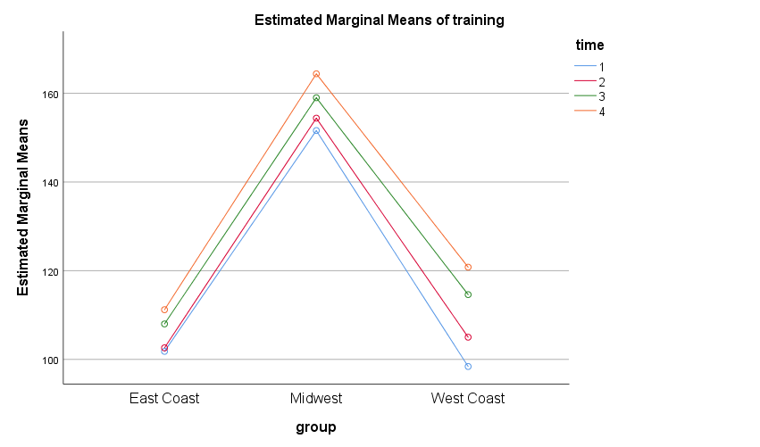

|  |  |  |  |  |  |  |
| --- | --- | --- | --- | --- | --- | --- |
| **Multiple Comparisons** | | | | | | |
| Measure: training | | | | | | |
| Tukey HSD | | | | | | |
| (I) group | (J) group | Mean Difference (I-J) | Std. Error | Sig. | 95% Confidence Interval | |
| Lower Bound | Upper Bound |
| East Coast | Midwest | -51,45* | 15,633 | ,016 | -93,16 | -9,74 |
| West Coast | -3,80 | 15,633 | ,968 | -45,51 | 37,91 |
| Midwest | East Coast | 51,45* | 15,633 | ,016 | 9,74 | 93,16 |
| West Coast | 47,65* | 15,633 | ,025 | 5,94 | 89,36 |
| West Coast | East Coast | 3,80 | 15,633 | ,968 | -37,91 | 45,51 |
| Midwest | -47,65* | 15,633 | ,025 | -89,36 | -5,94 |
| Based on observed means.  The error term is Mean Square(Error) = 611,006. | | | | | | |
| *. The mean difference is significant at the ,05 level. | | | | | | |

Interpretation

The average combined of group (East coast and Midwest) and (Mid-west and West coast) *M=-54.45 SD= 15.633 p=0.16* is significantly higher than the average combined of group (West coast and East coast) *M=3.80, SD=15.633 p=.968*  on trainings.

1. Nested ANOVA

Addressing the assumption

|  |  |  |  |  |  |  |
| --- | --- | --- | --- | --- | --- | --- |
| **Tests of Normality** | | | | | | |
|  | Kolmogorov-Smirnova | | | Shapiro-Wilk | | |
| Statistic | df | Sig. | Statistic | df | Sig. |
| Productivity_Scores | ,136 | 135 | ,000 | ,925 | 135 | ,000 |
| a. Lilliefors Significance Correction | | | | | | |

Interpretation

Interpretation

The tests of normality were carried out by Kolmogorov- Simonov test and Shapirio-wilk and the results shows the test of normality is not valid since at alpha 0.5 level for all training *p <.05.*

This is cause due to the Extreme values and its resulted high leverage and hence recorded as an outlier.

|  |  |  |  |  |
| --- | --- | --- | --- | --- |
| **Extreme Values** | | | | |
|  | | | Case Number | Value |
| Productivity_Scores | Highest | 1 | 24 | 97,00 |
| 2 | 65 | 95,00 |
| 3 | 77 | 95,00 |
| 4 | 87 | 95,00 |
| 5 | 83 | 94,00a |
| Lowest | 1 | 79 | 34,00 |
| 2 | 35 | 34,00 |
| 3 | 85 | 35,00 |
| 4 | 33 | 35,00 |
| 5 | 133 | 36,00b |
| a. Only a partial list of cases with the value 94,00 are shown in the table of upper extremes. | | | | |
| b. Only a partial list of cases with the value 36,00 are shown in the table of lower extremes. | | | | |

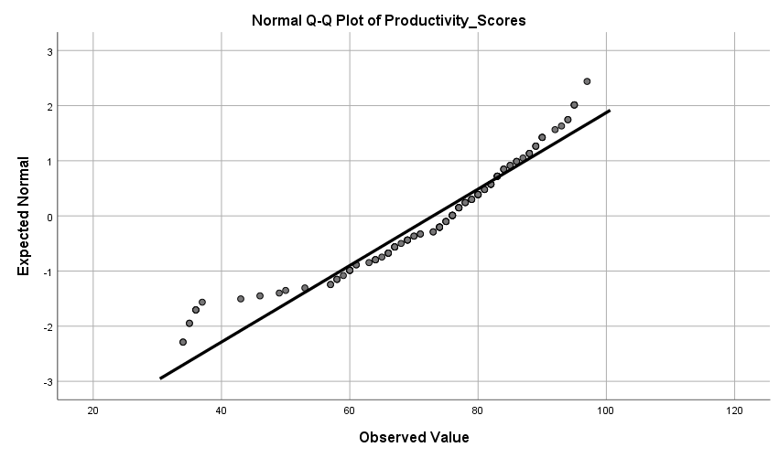

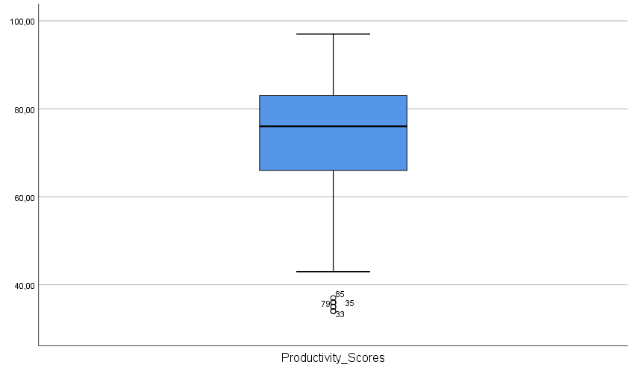the assumption of normality is not valid.

Test of homogeneity of variance

|  |  |  |  |  |  |
| --- | --- | --- | --- | --- | --- |
| **Levene's Test of Equality of Error Variancesa,b** | | | | | |
|  | | Levene Statistic | df1 | df2 | Sig. |
| Productivity_Scores | Based on Mean | 1,319 | 8 | 126 | ,240 |
| Based on Median | ,882 | 8 | 126 | ,534 |
| Based on Median and with adjusted df | ,882 | 8 | 76,380 | ,536 |
| Based on trimmed mean | 1,106 | 8 | 126 | ,364 |
| Tests the null hypothesis that the error variance of the dependent variable is equal across groups. | | | | | |
| a. Dependent variable: Productivity_Scores | | | | | |
| b. Design: Intercept + Department + Manager + Department * Manager | | | | | |

Interpretation

The test of equal variance was carried out with Levene’s test of equality, the result show that the assumption is valid since *F (8,126) =1.319, p=.240*

**Notes**

**Normality test can be corrected if the outliers are removed and hence, we can estimate our test of assumption again. After removing the extreme values and even transformation was applied the assumption is still invalid. Thus we can vividly say the assumption of independence is violated so the data is not useful, we only need to improvise new data and The Nested Anova analyse result is inconclusive.**

|  |  |  |  |  |
| --- | --- | --- | --- | --- |
| **Descriptive Statistics** | | | | |
| Dependent Variable: Productivity_Scores | | | | |
| Department | Manager | Mean | Std. Deviation | N |
| Marketing | Manager A | 61,1333 | 12,77199 | 15 |
| Manager B | 73,0000 | 11,38294 | 15 |
| Manager C | 65,7333 | 17,01036 | 15 |
| Total | 66,6222 | 14,47771 | 45 |
| Research and Development | Manager D | 77,4000 | 12,73802 | 15 |
| Manager E | 78,4000 | 8,00714 | 15 |
| Manager F | 82,2667 | 19,75734 | 15 |
| Total | 79,3556 | 14,16807 | 45 |
| Shipping | Manager G | 73,3333 | 8,27791 | 15 |
| Manager H | 69,0000 | 12,56412 | 15 |
| Manager I | 76,5333 | 13,51119 | 15 |
| Total | 72,9556 | 11,82631 | 45 |
| Total | Manager A | 61,1333 | 12,77199 | 15 |
| Manager B | 73,0000 | 11,38294 | 15 |
| Manager C | 65,7333 | 17,01036 | 15 |
| Manager D | 77,4000 | 12,73802 | 15 |
| Manager E | 78,4000 | 8,00714 | 15 |
| Manager F | 82,2667 | 19,75734 | 15 |
| Manager G | 73,3333 | 8,27791 | 15 |
| Manager H | 69,0000 | 12,56412 | 15 |
| Manager I | 76,5333 | 13,51119 | 15 |
| Total | 72,9778 | 14,41831 | 135 |

|  |  |  |  |  |  |  |  |  |  |
| --- | --- | --- | --- | --- | --- | --- | --- | --- | --- |
| **Tests of Between-Subjects Effects** | | | | | | | | | |
| Dependent Variable: Productivity_Scores | | | | | | | | | |
| Source | | Type III Sum of Squares | df | Mean Square | F | Sig. | Partial Eta Squared | Noncent. Parameter | Observed Powerc |
| Intercept | Hypothesis | 718977,067 | 1 | 718977,067 | 2536,174 | ,000 | ,998 | 2536,174 | 1,000 |
| Error | 1700,933 | 6 | 283,489a |  |  |  |  |  |
| Department | Hypothesis | ,000 | 0 | . | . | . | . | . | . |
| Error | . | . | .b |  |  |  |  |  |
| Manager | Hypothesis | 1700,933 | 6 | . | . | . | . | . | . |
| Error | . | . | .b |  |  |  |  |  |
| Department * Manager | Hypothesis | ,000 | 0 | . | . | . | . | . | . |
| Error | . | . | .b |  |  |  |  |  |
| a. MS(Manager) | | | | | | | | | |
| b. Cannot compute the appropriate error term using Satterthwaite's method. | | | | | | | | | |
| c. Computed using alpha = ,05 | | | | | | | | | |

**Results inconclusive**.